**Steps to follow for Initial project set up**

1. Install **latest** version of XAMPP
2. Open Command Prompt
3. Execute following command, “**cd C:\xampp\htdocs\dedications**”. This will change the current CMD directory to project folder.
4. Go to this [link](https://getcomposer.org/download/)
5. Copy and paste below code from the above link and execute it in the CMD

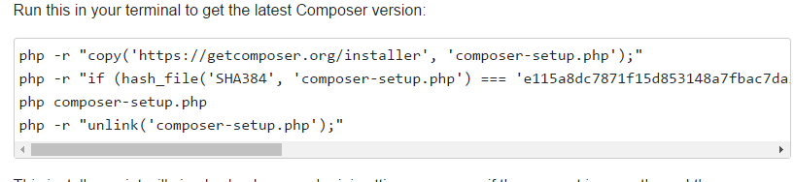

1. To verify if composer has installed successfully in your project directory check presence of following file in the directory:
   1. composer.phar
2. Again in the CMD execute the below command,
   1. **php composer.phar require slim/slim**
3. Following files or folder will be generated inside the project directory on successful execution of above command
   1. Vendor
   2. composer.json
   3. composer.lock
4. **Setting up virtual host**
   1. Create an .**htaccess** file (already present in the code base/ repository)
   2. Go to **xampp -> apache -> conf -> extra**
   3. Take back up of **httpd-vhosts.conf**
   4. Modify **https-vhosts.conf**

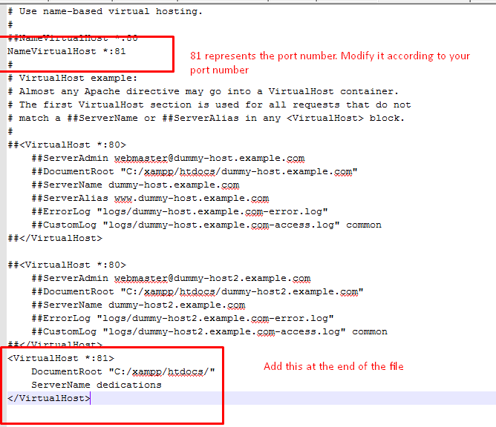



* 1. Go to the folder: **C:\Windows\System32\drivers\etc**
  2. Take back up of **hosts** file
  3. Modify **host** file (If error occurs while modifying inside current folder, copy it somewhere outside and then modify)

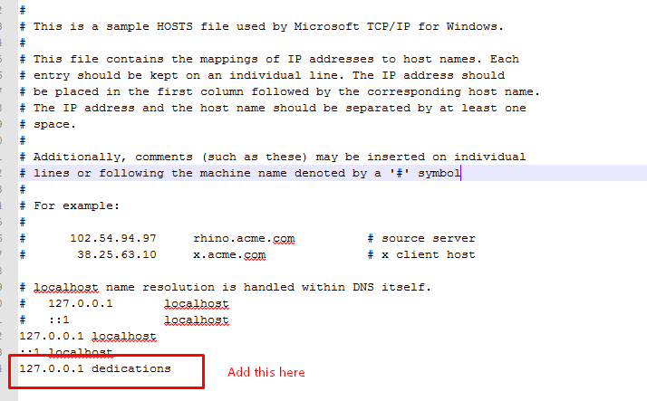

* 1. Stop and restart apache server

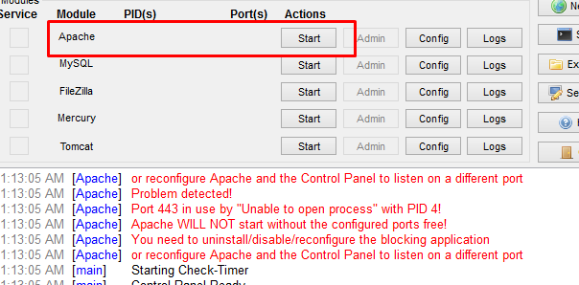

* 1. Apache should run successfully
  2. To verify if everything works properly, fire the below API (**Modify the port number accordingly**)
     1. <http://dedications:81/dedications/insite/api/giftcards>

**Reference:**

1. <http://www.slimframework.com/docs/tutorial/first-app.html>
2. <https://www.youtube.com/watch?v=TcFUNG7M3VE>